Split: Reconciling Identity in The Two Fridas

This paper was submitted for the fulfillment of the Final Research Paper Assignment for Modern Art II. Through the imagery and symbolism in The Two Fridas, I argue that Kahlo presents a portrait that reconciles the conflicting dualities in her life.

Jenna Gilley
ART 242: Modern Art II
December 4, 2018

*WRITING SAMPLE*
The following is a writing sample from my Junior Art History Thesis. I believe it shares my knowledge of modern art history and ability to write clearly and effectively. It should be used as a testament to my writing ability only. The copying or printing of this material without the owner’s consent is prohibited. Please contact me if you wish to site this paper in academic research.

Frida Kahlo’s 1939 painting The Two Fridas is one of many self-portraits in which the artist explores her complex personal identity. Although today she is considered one of the most influential Latin American artists of all time, Kahlo constantly lived in her husband Diego Rivera’s shadow. Her art was one of the few places where she could examine her individuality—as both an artist and person. Much of the scholarly work on Kahlo has been focused on how the artist’s physical pains are an essential aspect of her work. Yet, Kahlo’s identity is not defined by her physical limitations. Themes of conflict between the disparate aspects of her relationship, heritage, and gender constructions are far more imperative in Kahlo’s paintings. Through the imagery and symbolism in The Two Fridas, Kahlo presents a portrait that reconciles the conflicting dualities in her life.
The Two Fridas (Figure 1) is one of Kahlo’s largest works, containing two almost life-sized versions of the artist seated on a bench against an ambiguous stormy-gray background. They are turned towards each other, gazing directly out at the viewer: united yet separate. The figure on the left wears a prim white Victorian style of European dress, while the figure on the right wears the indigenous Mexican Tehuantapec blouse and skirt in contrasting rich hues. Two vibrant red hearts stand out against the women’s chest, the left split open while the right is whole, linked by a trailing vein. The European Frida clamps the bleeding end of one vein with surgical clamps to stifle the blood flow, yet some still leaks out, staining her pastel pink skirt. The other Frida also holds an item: a black and white photograph of Diego Rivera. The women’s remaining hands are clasped together, in almost the center of the picture plane.
There is a consensus among scholars that these two depictions are meant to represent the Mexican and European sides of Frida’s heritage, one side Diego Rivera loved and the other that he rejected. Although the focus of this paper is not on the soap-opera nature of Rivera and Kahlo’s relationship (albeit entertaining), it is impossible to reconcile this painting without briefly touching on the couple’s tumultuous relationship. Kahlo and Rivera had long experienced bouts of infidelity in their marriage. Finally reaching a breaking point in 1938, Rivera filed for divorce, citing that he wanted to “be free to carry on with any woman who caught my fancy”, in addition to believing that the break would be beneficial for both artist’s careers . The Two Fridas was completed just days after the divorce papers arrived at Kahlo’s studio. Art historian MacKiney Helm was there to witness the event and wrote, “Frida was decidedly melancholy…when the divorce papers arrived, while we were looking at the picture, I half expected her to seize the dripping instrument and fling it across the room”. Kahlo was known to paint the things in her life that pained her, and her relationship was no exception. But far from painting a picture only on her grief in this difficult moment, The Two Fridas acknowledges heartbreak while celebrating a newfound strength in herself.
Kahlo loved Diego Rivera deeply, and clearly, her pain can be understood through this painting as well as in life. During their separation, she frequently sent love letters with her famous red lipstick kiss professing her desperate desire to be remarried. Images of violence exhibit her hurt in The Two Fridas. European Frida’s literal “broken” heart is vulnerably exposed, caused by Rivera’s rejection. The vein that trails from the heart encircles Kahlo’s neck dangerously, like a thin rope about to be pulled tight. On the Mexican Frida, the vein wraps around her arm, only to be severed at the small photo of Diego Rivera in her proper left hand. In an interesting association, Herrera cites Kahlo in a letter to Rivera, saying, “My blood is the miracle that travels in the veins of the air from my heart to yours”. European Frida is at risk of bleeding to death due to the literal severing of her vein from Diego, as the surgical clamp which attempts to stifle the dripping severed vein do so unsuccessfully.
The resulting pooling blood and the hearts themselves are reminiscent of the Aztec rituals of blood sacrifice, where blood was collected and given as a form of appeasements to the gods. As a willing victim, Kahlo offers up her life for the pleasing of Rivera, the “god” who she worshipped. As Herrera said, “Even when she hated him, Frida adored Diego, and that the pivot of her existence was her desire to be a good wife for him”. Aztec and other Pre-Colombian imagery is a common theme in Kahlo’s work, as well as other Mexican Revolutionary artists. The alignment with Aztec symbols of death like the bleeding heart and calaveras, or skull, was a reference to Mexican nationalism against Spanish imperialism. In this example, however, the heart can also be associated with passion. Kahlo had both the Spanish “hot caring” for her country as she did in her relationship with Rivera.
But the painting does not leave off with forlorn heartbreak. The Frida’s faces are stoic, strong, and impassive. Kahlo could have chosen to depict the women with tears streaming down their faces, as she does in Memory of the Heart—a very similar painting in terms of iconography (Figure 2)—yet instead, they peer haughtily outwards, without a trace of pain in their expression. Additionally, the Fridas’ clasped hands in the center emphasize a united stance against those who challenge them, specifically their betrayer: Rivera. Kahlo is frequently quoted saying, “There have been two great accidents in my life. One was the trolley, and the other was Diego. Diego was by far the worst.” Why then does Kahlo choose to depict herself as calm and collected while she bleeds? I would argue that it is because Kahlo is finally able to acknowledge and accept both parts of her identity, which she could not do while her and Rivera were still together. Memory of the Heart was completed two years prior to the couple’s divorce, when Kahlo discovered her husband having an affair with her sister Christina. In it, Kahlo stands alone in a barren landscape. Both European and Tehuana clothes are present, as in The Two Fridas.

Images
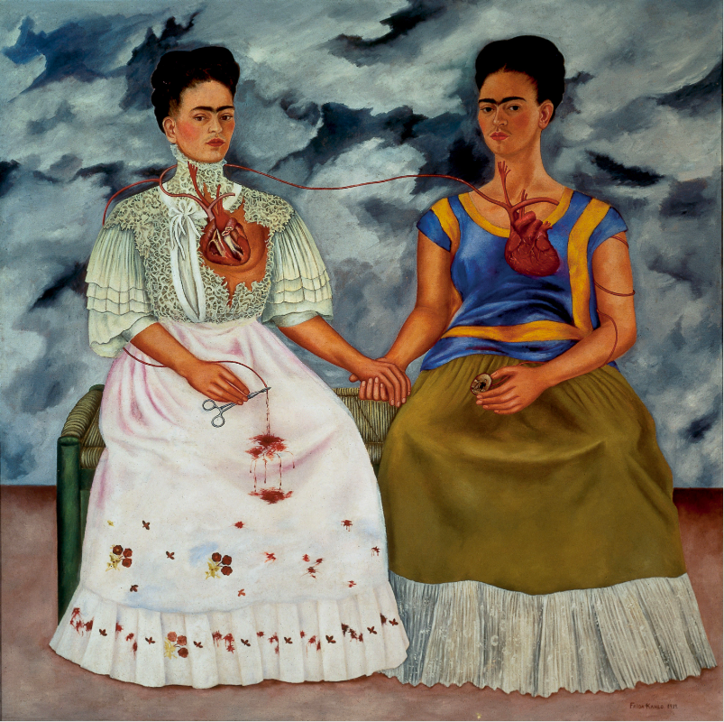
Figure 1: The Two Fridas, Frida Kahlo, 1939, oil on canvas,
173.5 cm × 173 cm, Museo de Arte Moderno, Mexico City

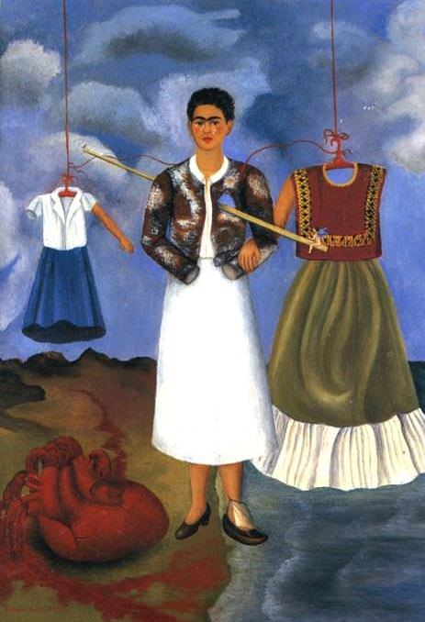
Figure 2: Memory of the Heart, Frida Kahlo, 1937, Oil on metal, 40 x 28 cm, private collection

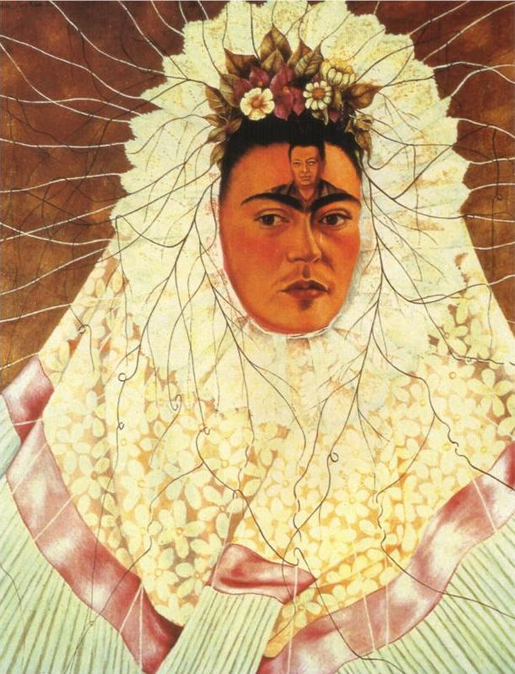
Figure 3: Self Portrait as a Tehuana, Frida Kahlo, 1943, oil on Masonite, 76 × 61 cm

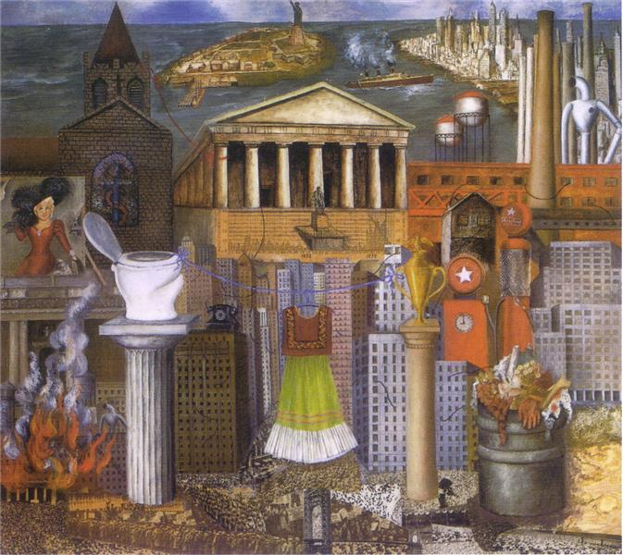
Figure 4: My Dress Hangs There, Frida Kahlo, 1933, collage and oil on Masonite, 46 x 55 cm, Hoover Gallery, San Francisco, CA

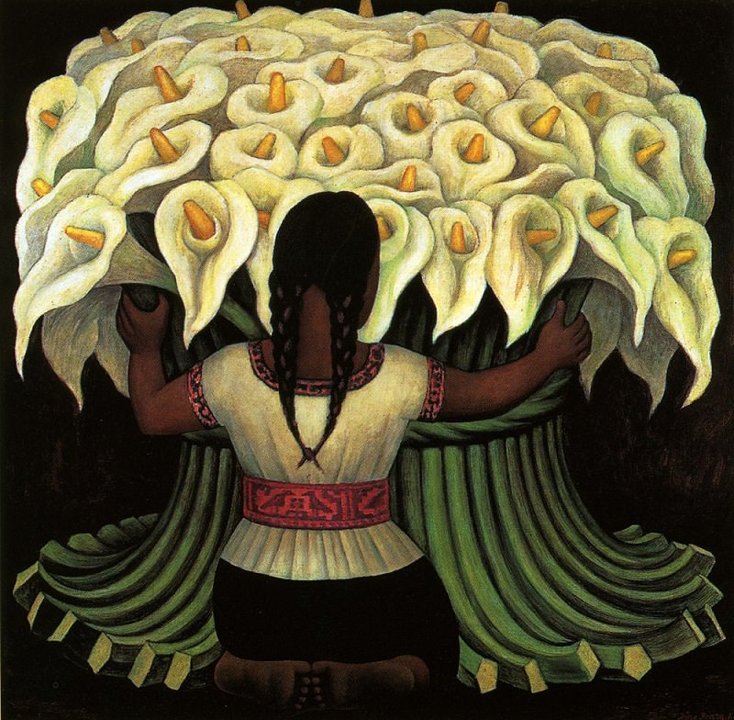
Figure 5: The Flower Seller, Diego Rivera, 1941, oil on Masonite, 48 x 48 in, Norton Simon Museum, Gift of Mr. Cary Grant

Bibliography

Andersen, Corrine. “Remembrance of an Open Wound: Frida Kahlo and Post-Revolutionary Mexican Identity.” South Atlantic Review 74, no. 4 (2009): 119–30.

Bakewell, Liza. “Frida Kahlo: A Contemporary Feminist Reading.” Frontiers: A Journal of Women Studies 13, no. 3 (1993): 165. https://doi.org/10.2307/3346753.

Block, Rebecca, and Lynda Hoffman-Jeep. “Fashioning National Identity: Frida Kahlo in ‘Gringolandia.’” Woman’s Art Journal 19, no. 2 (1998): 8–12. https://doi.org/10.2307/1358399.

Graulich, Michel. “Aztec Human Sacrifice as Expiation.” History of Religions 39, no. 4 (2000): 352–71.

Haynes, Anna. “Frida Kahlo: An Artist ‘In Between,’” no. 6 (n.d.): 18.

Helland, Janice. “Aztec Imagery in Frida Kahlo’s Paintings: Indigenity and Political Commitment.” Woman’s Art Journal 11, no. 2 (1990): 8–13.

Herrera, Hayden. Frida: A Biography of Frida Kahlo. New York: Harper Perennial, 2002.

James, Sibyl. “Painting the Town Red.” Edited by Hayden Herrera. The Women’s Review of Books 1, no. 4 (1984): 6–7. https://doi.org/10.2307/4019426.

Kahlo, Frida, Carlos Fuentes, and Sarah M Lowe. The Diary of Frida Kahlo: An Intimate Self-Portrait. New York; Mexico: Harry N. Abrams ; La Vaca Independiente, 2001.

Kettenmann, Andrea, and Frida Kahlo. Frida Kahlo, 1907-1954: Pain and Passion. Taschen, 2000.

Latimer, Joanna. “Unsettling Bodies: Frida Kahlo’s Portraits and In/Dividuality.” The Sociological Review 56, no. 2_suppl (October 2008): 46–62. https://doi.org/10.1111/j.1467-954X.2009.00815.x.

LIPSETT-RIVERA, SONYA. “Power, Sex, Hair, and Clothes.” In Gender and the Negotiation of Daily Life in Mexico, 1750-1856, 211–48. University of Nebraska Press, 2012. https://doi.org/10.2307/j.ctt1d9nr16.11.

Pankl, Lis, and Kevin Blake. “Made in Her Image: Frida Kahlo as Material Culture.” Material Culture 44, no. 2 (2012): 1–20.

Synnott, Anthony. “Shame and Glory: A Sociology of Hair.” The British Journal of Sociology 38, no. 3 (1987): 381–413. https://doi.org/10.2307/590695.

Notes

Dot Tuer and Elliot King, ed. Frieda & Diego: Passion, Politics and Painting (Art Gallery of Ontario, 2012), 15
Lis Pankl and Kevin Blake, “Made in Her Image: Frida Kahlo as Material Culture,” Material Culture 44, no. 2 (2012): 11
Kettenmann and Kahlo, Frida Kahlo, 1907-1954. 278. Andrea Kettenmann and Frida Kahlo, Frida Kahlo, 1907-1954: Pain and Passion (Taschen, 1993). 17.
Tuer and King, Frieda & Diego, 16.
Herrera, Frida, 277.
Ibid. 277-278.
Ibid. 55.
Ibid. 278.
Michel Graulich, “Aztec Human Sacrifice as Expiation,” History of Religions 39, no. 4 (2000): 352.
Janice Helland, “Aztec Imagery in Frida Kahlo’s Paintings: Indigenity and Political Commitment,” Woman’s Art Journal 11, no. 2 (1990): 8
Sibyl James, “Painting the Town Red,” ed. Hayden Herrera, The Women’s Review of Books 1, no. 4 (1984): 6, https://doi.org/10.2307/4019426.
Corrine Andersen, “Remembrance of an Open Wound: Frida Kahlo and Post-Revolutionary Mexican Identity,” South Atlantic Review 74, no. 4 (2009): 122.
Frida Kahlo, Carlos Fuentes, and Sarah M Lowe, The Diary of Frida Kahlo: An Intimate Self-Portrait (New York; Mexico: Harry N. Abrams ; La Vaca Independiente, 2001): 20.

