*WRITING SAMPLE*
The following is a writing sample from my Senior Art History Thesis. I believe it is the culmination of my knowledge on art and fashion history, close looking skills, and ability to write clearly about art. It should be used as a testament to my writing ability only. The copying or printing of this material without the owner’s consent is prohibited. Please contact me if you wish to site this paper in academic research.

Jenna Gilley
12/9/19
Slipping On: Feminine Performance in Andy Warhol’s Shoe Drawings
Before he was the eccentric founder of Pop Art, Andy Warhol was an ad man—and a highly successful one. He made more money during the 1950s doing fashion illustrations than in most other periods of his art career. The ad industry was a perfect place for Warhol, because it was centered around fantasy, fun, and falsity. Steeped in starlet celebrity from a young age, Warhol recognized that being a “woman” is largely dependent on one’s glamour, an ideal feminine façade. Judith Butler in her famous essay on gender performance repeats Simone Beauvoir’s claim that one is not born a woman, but becomes one through repeated acts. The media, more specifically the fashion industry, is a key definer of repeated gender performance. Advertisers have pitched the same idea of identity altering to female consumers for decades. Changing oneself is as easy as buying a new dress, or perhaps in relation to the most common feminine stereotype, slipping on a new pair of shoes. The many shoe drawings of Andy Warhol have remained understudied in comparison to some of his other works, such as the Campbell’s Soup Cans or celebrity portraits, yet they convey much about his understanding of gender and sexuality. I argue that the success of Andy Warhol as a commercial artist was due to his understanding and use of feminine performance, seen through his glamourous and campy shoe drawings of the 1950s.
The shifting, gendered consumer culture of post-World War II America helped Warhol’s advertisements grow in popularity. During the 1940s, with husbands and male work force away, women’s fashion became all about practicality. American women did not have money to spend on unnecessary goods like trendy fashions. Clothes were simple and functional, based off of the utility clothes produced during war rationing. Women were encouraged to make clothes themselves and conserve fabric whenever possible. The resulting designs were plain and pragmatic, easy for the everyday person to wear and make (Figure 1). Additionally, women’s fashion began adopting characteristics of men’s fashion. Tailored suits with squared shoulders became the norm in women’s professional wear. The broadened shoulders and structured silhouette gave women a strong appearance similar to their male counterparts, much different from the flowing dresses of the 1930s. Pants also gained mass popularity for the first time in women’s fashion in the 1940s. With many women replacing men in factory jobs and some even serving in the military, pants became a work necessity. They helped a working woman remain modest and comfortable. Gender distinctions in clothing were blurring more than ever before.
However, after the war, things changed. America adopted a Keynesian model that encouraged citizens to help rebuild the economy through a “ferocious capitalism”. The middle class envisioned a new life of comfort, where their secure status could be defined by shiny kitchen appliances and a well-dressed family. With the influx of consumer goods, and therefore more competition, as Brad Collins put it, the advertising industry boomed into its own culture “so pervasive, persistent, and compulsive that it had to be noticed”. This advertising world was geared toward a specific female audience (Figure 2).With most resuming their role as homemakers after the men returned from war, women were the prime consumers of the family, in charge of purchasing everything from food to furniture. They were responsible for defining the appearance of the family, as well as their own. Now released from mandated and social obligation to be conscious with spending, women had more freedom to purchase more fanciful designs. Fashion became about fun again. Through this cloak of playful frivolity, the fashion industry subtly reestablished gender norms. Women’s fashion began to re-champion feminine details, which, as I will show, Warhol excelled in.
Warhol’s first job in New York was drawing shoes for Glamour magazine. I find it immensely ironic that of all fashion merchandise, it would be shoes that Warhol was tasked with drawing. Not only are they the most iconic feminine accessory, but it was known that Andy Warhol had a foot fetish. Dozens of foot drawings, male and female, can be seen in Warhol’s notebooks throughout the 50s, so many in fact that he made a Foot Book containing a selection of his favorite. The only other subject that he formed a book of would be drawings of male genitalia. Shoes also seem to have had a sexual appeal for Warhol. They not only encased a desirable part of the human body, but function as a representation of the wearer themselves. They have evidence of the person’s travels, retain the shape of the foot, and, as with all clothing, showcase a person’s particular style. Therefore, they are a perfect conduit for identity shifting. The more they are worn, the more the wearer becomes evident in the shoe. Bockris’ biography interestingly recounts that Warhol found kissing his lover’s shoes particularly erotic. It is no surprise then that when tasked to draw shoe advertisements in the early 50s, the resulting images emphasize the sensual aspect of footwear. For a person in advertising needing to book jobs, Warhol’s skill was immensely useful. After all, sex sells.
In his first advertisement for Glamour magazine, five women’s shoes of various styles ascend up three zig-zagging ladders (Figure 3). This pun refers to the corresponding article, “What is Success?”, which discusses the various ways a woman can be successful—in her career, in the home, and above all else, in love. Warhol’s shoes stand in for the middle class working women of Glamour’s audience. While different, each shoe is appropriate for wear in the workplace. All are heeled, giving a professional feminine silhouette, yet they are not too tall or thin, making them comfortable daytime attire. Besides their rough black outlines, each shoe is colored in a vivid red, popping against the white ground. Red of course is the color of passion. It is interesting that Warhol has chosen the most sexual hue to color his professional shoes. A successful working woman, then, is not only good at her job, but well-dressed, sophisticated, and still sexy. This idea is further replicated in the article itself, where the writer concludes her introduction with the statement, “And finally, incurable romantics that we [women] are, we talk about success in love—than which there is no greater reward for any of us”. Of course, we must take this comment in its historical context in the much more misogynistic 1950s, but it is important in showcasing one of the key aspects of feminine performance. To be a woman means looking enticing to men.
More examples can be seen in following jobs. In 1955, Warhol secured a huge account with I. Miller, a fashionable Manhattan shoe store. I. Miller catered to a more upscale audience than Glamour. Subsequently, their advertisements needed a different look—sleeker, more elegant. Warhol took note. His drawings shift away from heavy, blocky shapes into simplistic renderings with flowing, clean lines. One example can be seen in Figure 4. The sleek, black and white illustration shows a pair of legs in impossibly thin heals, feet slightly opened. The eye is immediately drawn to the shoes because of their dark coloring and the immense amount of negative space surrounding them. In fact, we almost forget that a woman is wearing them. Her legs have been reduced to a few slender, gently curving lines. The rest of her body is cut off, leaving the mind to ponder where those lines lead. The drawing bears similarity to Erté’s elegant fashion illustrations of the 1920s, of which Warhol definitely would have known (Figure 5). Both place a heavy emphasis on elongation, taking the forms of the body into the realm of fantasy. Erte’s signature slender figures are reflected in Warhol’s stretched shoe vamp and sinuous leg and foot, free of convoluted, unappealing anatomy. The resulting image is delicate, elegant, and dramatic, in the most restrained way.
The text is also telling. According to the advertisement, “Evins’ wizardry is all curves, and all flattery.” All curves, suggesting the curving lines of woman’s body. The shoe’s scalloped side is similar to a sweetheart neckline on a woman’s dress, meant to show off her décolletage. The elongated vamp also streamlines the legs and emphasizes their thinness. All flattery, suggesting that again, women should buy this shoe because of its ability to make them more attractive. Claire McCardell, the primary shoe designer for I. Miller, even remarked that her spindly shoes should be chosen to please a husband or lover. While Warhol would probably not have any say in the text, other advertisers likely would have written the slogans to compliment the design. Situated amongst advertisements announcing the weddings of beautiful debutantes, the I. Miller advertisements ingeniously created an association between the brand and the content surrounding them. In these terms, it is not necessarily the good that is desired, but the desire the good creates. When a woman purchases a new pair of I. Miller shoes, she buys it not just because of necessity or beauty, but because it will help her feel more confident, elegant, “enticing”, which along which physically extenuating her shape, will make her more desirable. Warhol’s exceedingly minimalist illustration has managed to convey all of this to his female audience simply through line and form.
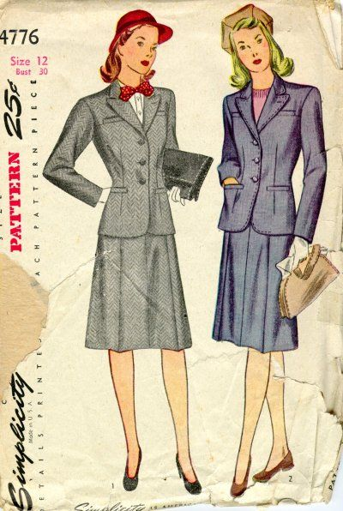
Images
Figure 1: Everyday female clothing pattern, Simplicity Patterns, mid-1940s, paper, unknown dimensions, unknown location

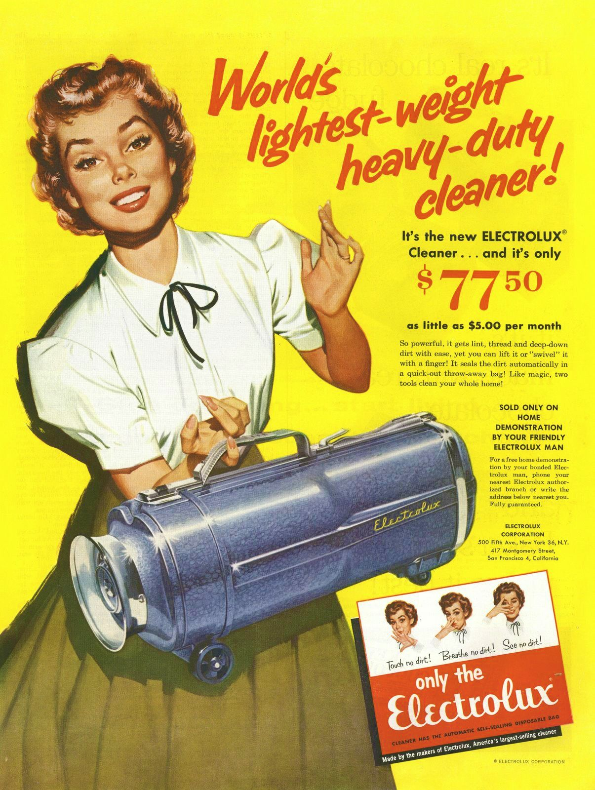
Figure 2: Electrolux advertisement, Electrolux Company, 1955, ink and on paper, unknown dimensions, public property

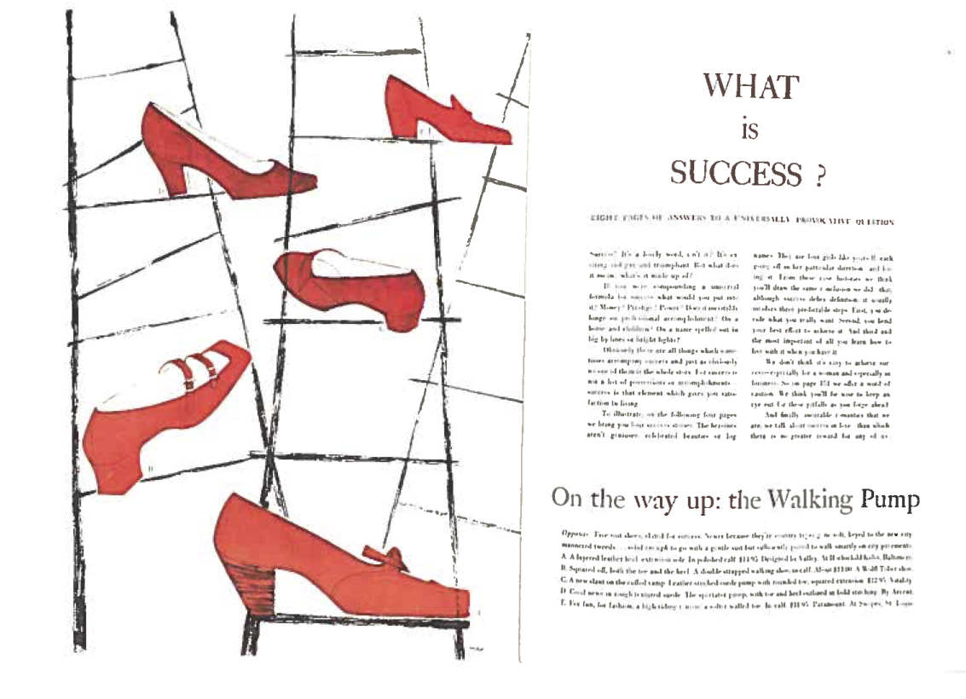
Figure 3: Shoe advertisement for Glamour magazine, Andy Warhol, 1949, dye-based ink on paper, unknown dimensions, collection of Paul Maréchal

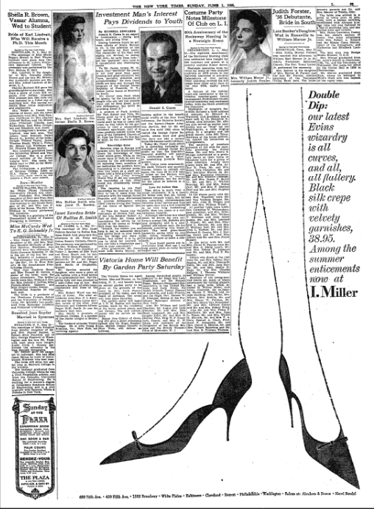
Figure 4: I. Miller advertisement, Andy Warhol, New York Times, June 1, 1958, ink and on paper, unknown dimensions, public property

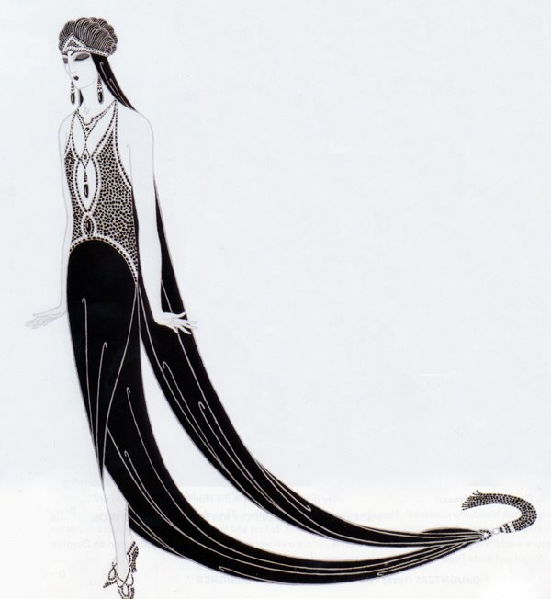
Figure 5: Costume designed for The Mystic, Erté, 1925, ink on paper, unknown dimensions, unknown location

Bibliography
Benstock, Shari, and Suzanne Ferriss. Footnotes: On Shoes. Rutgers University Press, 2001.

Bockris, Victor. Warhol: The Biography. Hachette Books, 2009.

Bolton, Andrew, Karen Van Godtsenhoven, Amanda Garfinkel, and Fabio Cleto. Camp: Notes on Fashion. Metropolitan Museum of Art, 2019.

Butler, Judith. “Performative Acts and Gender Constitution: An Essay in Phenomenology and Feminist Theory.” Theatre Journal 40, no. 4 (1988): 519–31. https://doi.org/10.2307/3207893.

Cohen, Lizabeth. A Consumers’ Republic: The Politics of Mass Consumption in Postwar America. 1st ed. New York: Knopf : Distributed by Random House, 2003.

Colacello, Bob. Holy Terror: Andy Warhol Close Up. Cooper Square Press, 1990.

Collins, Bradford. Pop Art. London ; New York: Phaidon Press, 2012.

De Salvo, Donna M., Paul Schimmel, Russell Ferguson, David Deitcher, Museum of Contemporary Art (Los Angeles, Calif.), Museum of Contemporary Art (Chicago, Ill.), and Whitney Museum of American Art, eds. Hand-Painted Pop: American Art in Transition, 1955-62. Los Angeles : New York: Museum of Contemporary Art ; Rizzoli International Publications, 1992.

De Salvo, Donna M., Andy Warhol, Whitney Museum of American Art, San Francisco Museum of Modern Art, and Art Institute of Chicago, eds. Andy Warhol: From A to B and Back Again. New York: Whitney Museum of American Art, 2018.

Gundle, Stephen. Glamour: A History. Reprint edition. Oxford: Oxford University Press, U.S.A., 2009.

Hollander, Anne. Seeing Through Clothes. University of California Press, 1993.

Klee, Paul, and Lars Müller Publishers. Pedagogical Sketchbook Bauhausbücher 2, 2019.

Krajewski, Sara, Richard Axsom, Jordan Schnitzer, Andy Warhol, and Brian Ferriso. Andy Warhol: Prints: From the Collections of Jordan D. Schnitzer and His Family Foundation. Edited by Carolyn Vaughn. Portland, Oregon: Jordan Schnitzer Family Foundation, 2017.

Martin, Richard. “Illuminations: Warhol in the 1950s”. Francis, Mark, Margery King, Andy Warhol, Andy Warhol Museum, Whitney Museum of American Art, Art Gallery of Ontario, and Barbican Art Gallery, eds. The Warhol Look: Glamour, Style, Fashion ; [Publ. on the Occasion of the Exhibition The Warhol Look ... Whitney Museum of American Art, New York, November 8, 1997 - January 18, 1998 ...]. A Bulfinch Press Book. Boston, Mass.: Bulfinch, 1997.

Meyer, Richard. Outlaw Representation: Censorship & Homosexuality in Twentieth-Century American Art. Ideologies of Desire. Oxford ; New York: Oxford University Press, 2002.

O’Connor, John, and Benjamin Liu. Unseen Warhol. New York: Rizzoli, 1996.

Pratt, Lucy, and Linda Woolley. Shoes. London: V & A Publishing, 2008.

Robertson, Pamela. “What Makes the Feminist Camp?”. Cleto, Fabio. Camp: Queer Aesthetics and the Performing Subject : A Reader. University of Michigan Press, 1999.

Sontag, Susan. Against Interpretation: And Other Essays. 1st edition. New York, N.Y: Picador, 2001.

The University of Vermont. “Women’s Clothing - 1940s - Clothing - Dating - Landscape Change Program.” Landscape Change Program. Accessed December 8, 2019. https://www.uvm.edu/landscape/dating/clothing_and_hair/1940s_clothing_women.php.

Warhol, Andy. America. Grove/Atlantic, Inc., 2015.

———. Fashion. Chronicle Books, 2004.

———. The Philosophy of Andy Warhol. First edition. Orlando: Harvest, 1977.

Notes Judith Butler, “Performative Acts and Gender Constitution: An Essay in Phenomenology and Feminist Theory,” Theatre Journal 40, no. 4 (1988): 522.
Lizabeth Cohen in her book A Consumers’ Republic: The Politics of Mass Consumption in Postwar America incudes a "Consumer Pledge Song" popular among women. The song urges minimal spending, mending your own clothes, and avoiding extravagance. 1st ed (New York: Knopf : Distributed by Random House, 2003) 68.
The University of Vermont, “Women’s Clothing - 1940s - Clothing - Dating - Landscape Change Program,” Landscape Change Program, accessed December 8, 2019, https://www.uvm.edu/landscape/dating/clothing_and_hair/1940s_clothing_women.php.
Ibid.
Phrase used by Collins from the book The Fifties (1993) by author and journalist David Halberstam, Bradford Collins, Pop Art (London ; New York: Phaidon Press, 2012), 24.
Bockris points out that the amount of money spent on advertising $9 billon. Victor Bockris, Warhol: The Biography (Hachette Books, 2009), 80.
Cohen, A Consumers’ Republic, 112.
So pervasive in fact that later, it would become its own art form in Pop. Collins, Pop Art, 24.
“Producers” were gendered as male while “consumers” were gendered as female. This is one of the reasons why commercial artist Warhol was shunned by male fine artists like Jasper Johns and Rosenquist. Donna M. De Salvo et al., eds., Hand-Painted Pop: American Art in Transition, 1955-62 (Los Angeles : New York: Museum of Contemporary Art ; Rizzoli International Publications, 1992) 196-197.
This is also interesting. Is it a coincidence that Warhol’s first job would be for a magazine titled Glamour? Victor Bockris, Warhol: The Biography (Hachette Books, 2009), 80.
Bockris, Warhol, 92.
Ibid.
Ibid.
Richard Martin, “Illuminations: Warhol in the 1950s” in Francis, Mark, Margery King, Andy Warhol, Andy Warhol Museum, Whitney Museum of American Art, Art Gallery of Ontario, and Barbican Art Gallery, eds. The Warhol Look: Glamour, Style, Fashion ; [Publ. on the Occasion of the Exhibition The Warhol Look ... Whitney Museum of American Art, New York, November 8, 1997 - January 18, 1998 ...]. A Bulfinch Press Book. Boston, Mass.: (Bulfinch, 1997), 70.
Donna M. De Salvo et al., eds., Andy Warhol: From A to B and Back Again (New York: Whitney Museum of American Art, 2018), 117.
Bockris, Warhol, 117.
Martin, "Illuminations", The Warhol Look, 71.
Janice West, “The Shoe in Art, the Shoe as Art” in Benstock and Ferriss, Footnotes, 44.
De Salvo et al., Andy Warhol, 134.

